New England Patriots Report: How to Fill the Seats
Intro
This analysis examines the New England Patriots’ financial investment into the team over the last 18 seasons and how that relates to team performance and fan behavior. The data spans from 2006-2024 (excluding 2020 due to COVID-19), including the peak of Tom Brady’s rule and the recovery post-mortem.

Test 1: Demand for Tickets
The data shows that ticket price and attendance have a strong negative correlation. During Brady’s dominant years, Gillette Stadium was home to some of the most dominant football on the planet. This led people to sell their tickets well above face value on resale sites such as Seat Geek, Ticketmaster, etc. However, fans weren’t willing to pay such a pretty penny to see winning football. When tickets were at their highest value in this 18 year span, Gillette saw its lowest attendance numbers.
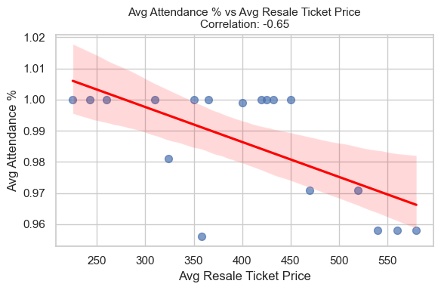

Test 2: Ownership vs Fan Passion
Team Payroll and attendance have a moderately negative correlation. In the years that Gillette was consistently sold out, most of these teams had a payroll below 150 million dollars.
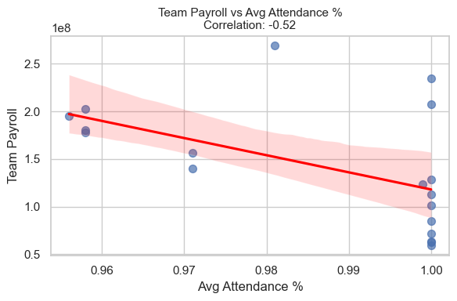

Test 3: Rallying for Winning Teams
Win percentage and attendance have a weak positive correlation. There is a small tendency for fans to show up more when the team is winning, but not significantly.
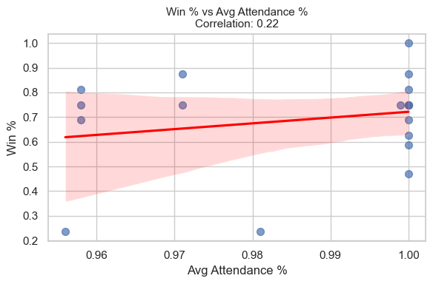

Test 4: Big Pockets, Small Stat lines
Winning percentage and payroll have a strong negative correlation. Higher payrolls have not directly led to better teams with successful records over the past few years.
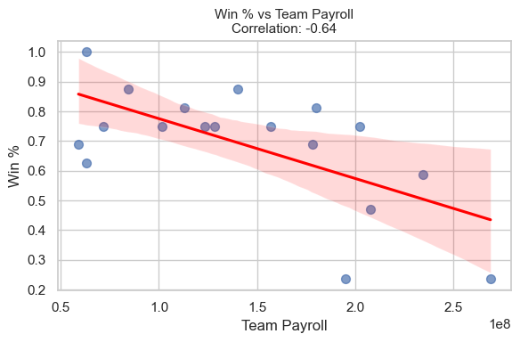

Key Takeaways
- Attendance vs Ticket Price
The strongest relationship observed (r = -.65) shows that attendance decline as the games become more expensive to go to. This indicates that Patriots fans are sensitive to trends in the secondary market, regardless of how their team is performance. While they may have some of the most loyal fans, the inflation of the resale market, especially in the Brady era, appears to have discouraged full attendance.
- Payroll vs Performance
The data reveals a surprising negative correlation (r = -.64) between team payroll and winning percentage. This may reflect the years post-Brady where many free agents were signed (think Jonnu Smith, Cam Newton, Hunter Henry, etc.) but the team’s performance declined. Spending has increased post-Brady but results have declined, showing the Patriots are seeing poor returns on investment.
- Performance and Fan Interest
A mild positive correlation (r = .33) exists between win percentage and ticket prices. Winning drives up the market, but not as strongly as expected. After such a long dynasty of success, the Patriots fanbase seems to have become numb to the winning and performance has smaller effects on turnout.
- Attendance Totals
Attendance correlates weakly with winning (r = .22) and negatively with payroll (r =-.52). This may mean that outside factors such as weather and ticket affordability more heavily influence attendance than the team’s performance and star-power.

Summary
From 2006-2024, the New England Patriots have seen their franchise shift from a seemingly unbreakable dynasty to a team struggling to find a true direction. The data implies that coming off of Brady’s dominance: high payrolls don’t guarantee wins, ticket affordability matters, and winning only slightly boosts interest. Beginning in the late 2010s, the end of Brady’s Patriots tenure, spending rose, wins dropped, and fans were more selective. With Drake Maye currently playing like an MVP candidate and a newfound excitement brewing in Foxboro after the lull, there is a lot of potential for this franchise to get to where they once were. The Kraft’s may consider making investments in gameday experience over player salary, and find other ways to bring in revenue than ticket prices.

